
Dashboard Design

Team ID | MCA
Project Name | Heart Disease Risk and Patient Health Analysis
Maximum Marks | 5 Marks

Creating an effective dashboard involves thoughtful design to ensure that the presented information is clear, relevant, and easily understandable for the intended audience. Here are some key principles and best practices for dashboard design
Activity 1: Interactive and visually appealing dashboards
Creating interactive and visually appealing dashboards involves a combination of thoughtful design, effective use of visual elements, and the incorporation of interactive features. Here are some tips to help you design dashboards that are both visually appealing and engaging for users so take care of below points
- Clear and Intuitive Layout
- Use Appropriate Visualizations
- Colour and Theming
- Interactive Filters and Slicers
- Drill-Down Capabilities
- Responsive Design
- Custom Visuals and Icons
- Use of Infographics

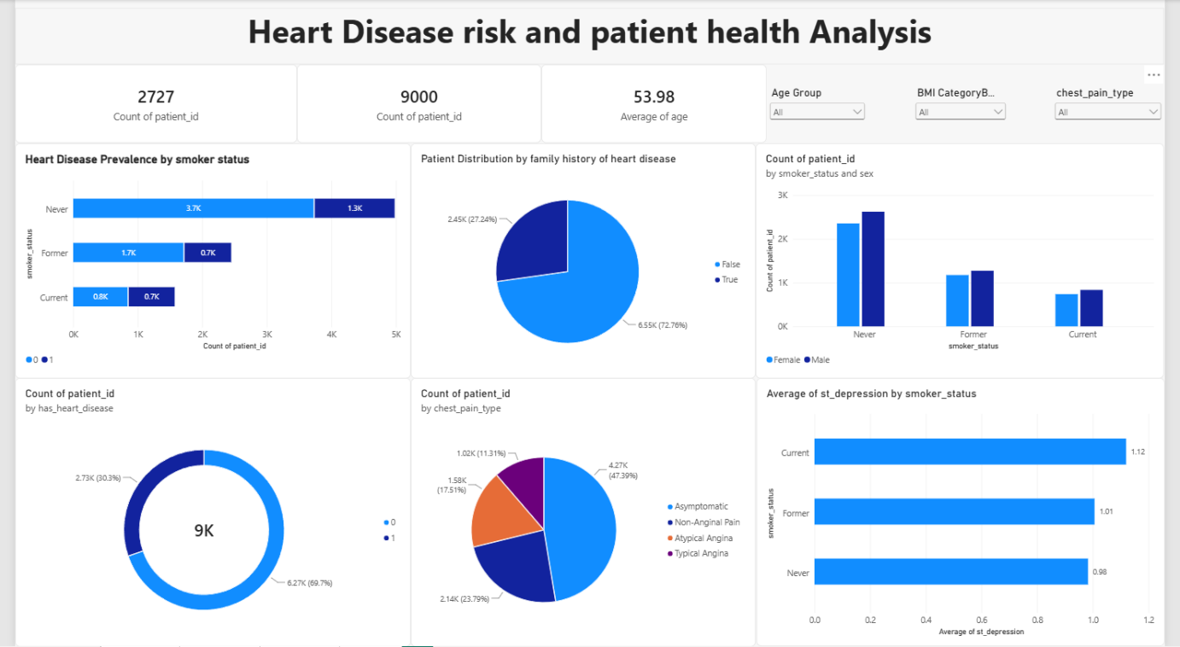
Key Metric Indicators (KPIs)
- High-Risk Patient Count (Heart Disease = 1): 2,727 patients
- Total Patient Sample Size: 9,000 patients
- Average Patient Age: 53.98 years
Dashboard Visualizations & Data Insights
- Heart Disease Prevalence by Smoker Status (Stacked Bar Chart)
  - Never Smokers: ~3.7K without heart disease vs. 1.3K with heart disease
  - Former Smokers: ~1.7K without heart disease vs. 0.7K with heart disease
  - Current Smokers: ~0.8K without heart disease vs. 0.7K with heart disease (representing the highest proportion of affected individuals relative to group size)
- Patient Distribution by Family History of Heart Disease (Pie Chart)
  - False (No Family History): 6.55K patients (72.76%)
  - True (Family History Present): 2.45K patients (27.24%)
- Count of Patients by Smoker Status and Sex (Clustered Bar Chart)
  - Across all categories (Never, Former, and Current smokers), the count of Male patients slightly exceeds that of Female patients.
- Overall Heart Disease Distribution (Donut Chart)
  - No Heart Disease (0): 6.27K patients (69.7%)
  - Heart Disease Present (1): 2.73K patients (30.3%)
- Count of Patients by Chest Pain Type (Pie Chart)
  - Asymptomatic: 4.27K patients (47.39%)
  - Non-Anginal Pain: 2.14K patients (23.79%)
  - Atypical Angina: 1.58K patients (17.51%)
  - Typical Angina: 1.02K patients (11.31%)
- Average ST Depression by Smoker Status (Horizontal Bar Chart)
  - Current Smokers: Highest average ST depression at 1.12
  - Former Smokers: Average ST depression of 1.01
  - Never Smokers: Lowest average ST depression at 0.98

